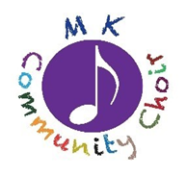
Milton Keynes Community Choir
Dates & fees: Spring 2021
Spring Term (7.20pm for 7.45 start)
5 January 2021 (term starts)
12 January
19 January
26 January
2 February
9 February
Half term
(no session on 16 February)
Spring Term resumes
23 February
2 March
9 March
16 March
23 March
30 March (final session of term)
(Easter Sunday is 4 April)

MKCC Fees
Spring Term
£48 (whole term)
£24 (half a term)
MKCC BACS details
Sort code: 30-15-53
Account: 55493268
Reference: ‘Subs’

If you are unable to pay by BACS, please send a
cheque (made out to ‘Milton Keynes Community Choir’) to
Liz Whitelegg. Please write your email address on the back of
the cheque if you’d like Liz to acknowledge receipt.

Thanks.

[Calendar/Fees published 20 January 2021]

